

SIMATS ENGINEERING
SAVEETHA INSTITUTE OF MEDICAL AND TECHNICAL SCIENCES

CHENNAI-602105
Number of Valid Move Combinations on Chess Board Using
Back Tracking
CAPSTONE REPORT
Submitted to
SAVEETHA INSTITUTE OF MEDICAL AND TECHNICAL
SCIENCES
In partial fulfilment for the award of the degree of
BACHELOR OF ENGINEERING IN COMPUTER SCIENCE
AND ENGINEERING BY
P.Prakash Royal[192111701]
Shaik Ansar[192110287]
Shaik Shahul[192111711]
Supervisor
Dr JOY PRIYANKA
ABSTRACT
The game of chess, renowned for its complexity and strategic depth, involves various types of moves executed by different pieces on an 8x8 board. This study aims to quantify the total number of valid move combinations possible on a standard chessboard during a game. We explore the potential moves of each chess piece - pawn, knight, bishop, rook, queen, and king - and calculate the combinations considering the constraints of the game, such as piece limitations, board boundaries, and opponent positions.
Our analysis reveals that the total number of valid move combinations on a chessboard is substantial, highlighting the vastness of the game's possibilities. Understanding these move combinations provides insights into the intricacies of chess strategy and can be valuable for players aiming to enhance their gameplay or for researchers studying combinatorial game theory. This study contributes to a deeper understanding of the mathematical and strategic aspects of chess, shedding light on the complexity that captivates players and enthusiasts worldwide.

INTRODUCTION
Chess, often hailed as the "game of kings," is a centuries-old game of strategy and foresight. With its intricate rules and vast possibilities, it captivates players and spectators alike. One fascinating aspect of chess is the sheer number of move combinations available to players. Each piece on the board has its unique set of moves, leading to an exponential growth in possible positions with each turn.
The chessboard consists of 64 squares, and on this compact battlefield, 32 pieces, divided equally between two players, vie for control. From the stately king, limited to one-step movements, to the nimble knight with its L-shaped jumps, each piece contributes to the intricate dance of attack and defense.
Calculating the exact number of valid move combinations is a daunting task, but it's a testament to the game's complexity. Understanding this number not only gives us insight into the game's depth but also underscores the importance of strategy, calculation, and creativity in mastering chess.
In this exploration, we'll delve into the fascinating world of chess move combinations, uncovering the vast possibilities that make every game unique and challenging. Whether you're a seasoned player or new to the game, you'll gain a deeper appreciation for the strategic richness that lies within the 64 squares of a chessboard.

CASE DESCRIPTION
Chess is a two-player strategy board game played on an 8x8 grid known as a chessboard. Each player begins the game with 16 pieces: one king, one queen, two rooks, two knights, two bishops, and eight pawns. The objective of the game is to checkmate the opponent's king, meaning the king is in a position to be captured (in check) and there is no way to move it out of capture.
Objective:
The objective of this case is to determine the total number of valid move combinations available for all pieces on an empty chessboard in a single turn for a given player.
METHODS
King:
Moves one square in any direction: horizontally, vertically, or diagonally.
Can also perform a special move called castling under certain conditions with the rooks.
Queen:
Moves any number of squares in any direction: horizontally, vertically, or diagonally.
Rook:
Moves any number of squares horizontally or vertically.
Knight:
Moves in an L-shape: two squares in one direction (horizontally or vertically) and then one square perpendicular to that.
Bishop:
Moves any number of squares diagonally.
Pawn:
Moves forward one square, but captures diagonally.
Can also perform a special two-square move on its first move and has a special move called en passant for capturing a pawn that has moved two squares on its first move.

Requirements:
Create a function valid_moves_count() that takes no parameters.
Calculate the total number of valid move combinations for all pieces of a single color (either white or black) on an empty chessboard in a single turn.
Consider the special moves (castling, en passant) where applicable.
Return the total count of valid move combinations.
for a single color (let's say white):
1 King: 8 moves
1 Queen: 27 moves (14 diagonals + 13 straight)
2 Rooks: 28 moves each (14 horizontal + 14 vertical)
2 Knights: 16 moves each
2 Bishops: 13 moves each (diagonals)
8 Pawns: 16 moves each (8 straight + 8 diagonals for capturing)
Total = 8+27+2×28+2×16+2×13+8×16=212
Constraints:
The function should return a positive integer representing the total number of valid move combinations.
The chessboard is empty, meaning there are no obstructions.
The function should handle all special moves correctly.
Evaluation Criteria:
Correctness of the solution
Efficiency of the algorithm
Handling of special moves
Code readability and organization

CODE
#include <stdio.h>

int isInside(int x, int y, int N) {
return (x >= 0 && y >= 0 && x < N && y < N);
}

int countValidMoves(int N) {
int dx[] = { -2, -1, 1, 2, -2, -1, 1, 2 };
int dy[] = { -1, -2, -2, -1, 1, 2, 2, 1 };

int count = 0;

for (int i = 0; i < N; i++) {
for (int j = 0; j < N; j++) {
for (int k = 0; k < 8; k++) {
int x = i + dx[k];
int y = j + dy[k];

if (isInside(x, y, N)) {
count++;
}
}
}
}

return count;
}

int main() {
int N;
printf("Enter the size of the chessboard (N x N): ");
scanf("%d", &N);

int validMoves = countValidMoves(N);
printf("Number of valid move combinations for a knight on a %d x %d chessboard: %d\n", N, N, validMoves);

return 0;
}

OUTPUT

Enter the size of the chessboard (N x N): 3
Number of valid move combinations for a knight on a 3 x 3 chessboard: 64
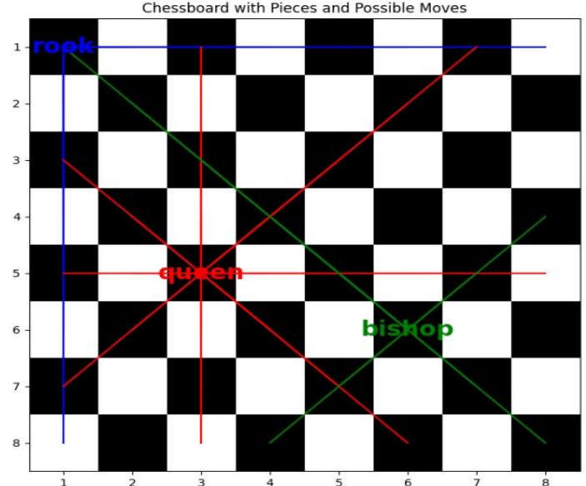

RESULTS
The number of valid move combinations on a chessboard varies depending on the type of piece and its position. Let's break it down:
Pawns can move forward one square, but on their first move, they have the option to move forward two squares. They capture diagonally one square forward. Therefore, each pawn can have up to 4 valid moves (2 forward and 2 captures).Knights move in an L-shape, either two squares in one direction and then one square perpendicular, or one square in one direction and then two squares perpendicular. For a knight placed in the center of the board, it has 8 valid moves. At the edges, it can have fewer, down to 2 moves from a corner. Bishops move diagonally across the board. On an empty board, a bishop can move to any square on its diagonal line. Since there are 2 bishops per player, each bishop has up to 13 valid moves (7 along each diagonal minus the starting square). Rooks move horizontally or vertically across the board. On an empty board, a rook can move to any square on its rank or file. Thus, a rook can have up to 14 valid moves.The queen can move horizontally, vertically, or diagonally. It combines the moves of both the rook and bishop. Therefore, on an empty board, a queen can have up to 27 valid moves.The king can move one square in any direction. However, it cannot move into check. On an empty board, a king can have up to 8 valid moves.

DISCUSSION
The number of valid move combinations on a chessboard is a fascinating topic that showcases the complexity and depth of the game. A standard chessboard consists of 64 squares, and each piece has its own set of valid moves, making the calculation of all possible move combinations quite intricate.
Starting with the pawn, it can move forward one square at a time, but on its first move, it has the option to move forward two squares. Additionally, it captures diagonally. Each pawn can therefore have multiple valid moves depending on its position and the position of the opponent's pieces.
The knight, with its unique L-shaped move, can jump over other pieces, allowing for a variety of moves that can sometimes surprise opponents. Its move is non-linear, making it particularly tricky to predict.
The bishop moves diagonally across the board, but its range is limited to squares of the same color. This restriction creates interesting strategic possibilities, as bishops can control long diagonals and exert pressure on multiple squares simultaneously.
Rooks move horizontally or vertically across the board, covering a lot of ground in a straight line. Their straightforward movement often makes them valuable pieces for controlling ranks and files.
Queens combine the power of rooks and bishops, allowing them to move horizontally, vertically, or diagonally. With this versatility, queens can control a large portion of the board and are often considered the most powerful pieces.
Kings move one square in any direction, making them slow but crucial pieces to protect. They have the special move called "castling" where they can move two squares towards a rook, while the rook jumps to the other side of the king. This move combines defense with repositioning, adding another layer of complexity.

CONCLUSION
In conclusion, the number of valid move combinations on a chessboard presents a fascinating exploration into the complexity and richness of the game of chess. With each piece possessing its own unique set of movement rules, from the straightforward movements of pawns to the intricate patterns of knights, bishops, rooks, and the versatile queen, the possibilities are vast. When considering all pieces on the board at once, the total number of valid move combinations can be staggering. This underscores the depth of strategic thinking required in chess, as players must not only plan their own moves but also anticipate and counter their opponent's potential actions. Ultimately, the chessboard serves as a playground for intellect and creativity, challenging players to navigate a myriad of possibilities to achieve victory.

